Integration RTR report CSV Extra ct steps.
Navigate to the Setup menu and open the Developer Console. From the Developer Console, click on the Debug menu and select Open Execute Anonymous Window. This will open a dialog box where you can enter your script. Once the script is entered, you can execute it directly from the dialog box.
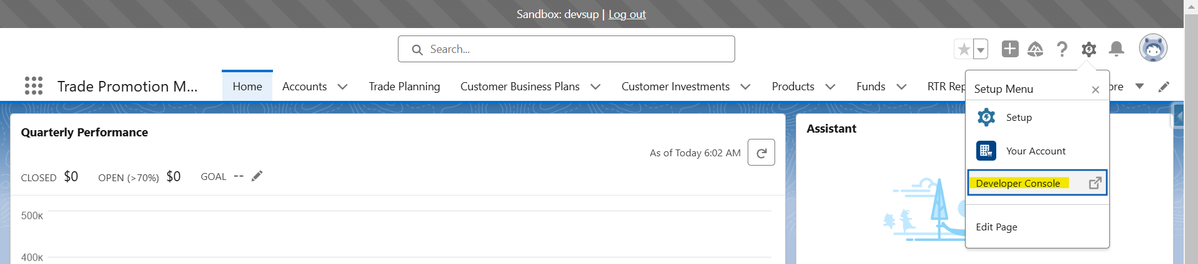
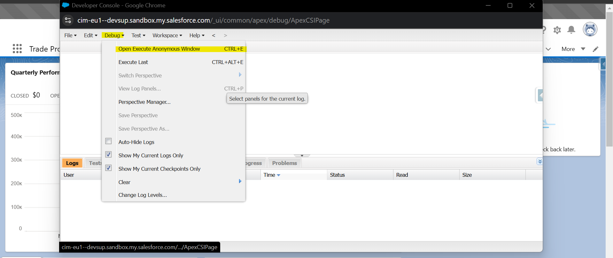
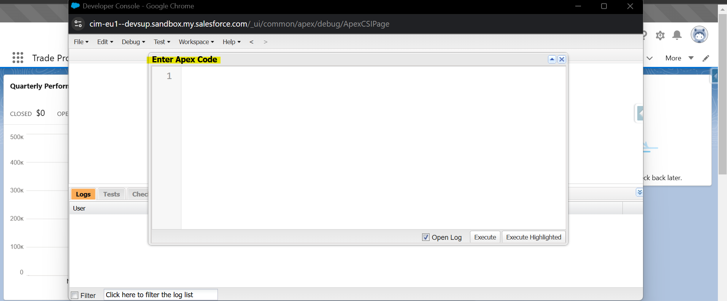

- SCHEDULE RTR EXPORT:
Execute the script below to schedule the RTR report, replacing the highlighted placeholder with the report name. After running the query, select Debug Only to retrieve the CSV GUID.

CGCLOUD.OffPlatformCallout request = new
CGCLOUD.OffPlatformCallout('SCHEDULE_RTR_EXPORT','DE00');
Map<String, Object> data = new Map<String, Object>();
data.put('metaname','CCEPAccountPlanKPIExtraction');
data.put('salesorg', 'DE00');
data.put('businessyear',2024);
data.put('backwardCompatibilityMode',true);
String requestBodyContent = JSON.serialize(data, true);
Map<String, String> params = new Map<String, String>();
CGCLOUD.OffPlatformCalloutResponse response = request.execute(CGCLOUD.TransactionHandler.getTransactionIdentifier(), params, requestBodyContent);
System.debug(response);

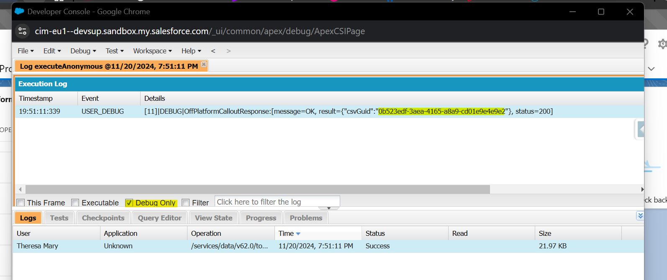

- GET RTR EXPORT STATUS:

Execute the script below to retrieve the RTR export status. Copy the CSV GUID obtained and replace it in the highlighted placeholder.

CGCLOUD.OffPlatformCallout request = new CGCLOUD.OffPlatformCallout('GET_RTR_EXPORT_STATUS','DE00');
Map<String, String> params = new Map<String, String>();
params.put('csvGuid', 'f06be932-1fe1-47bc-a219-c10cce75ae3b');
CGCLOUD.OffPlatformCalloutResponse response = request.execute(CGCLOUD.TransactionHandler.getTransactionIdentifier(), params, null);
System.debug(response);

You will receive a response like the one below. Once the status displays Ready, proceed to the next step.
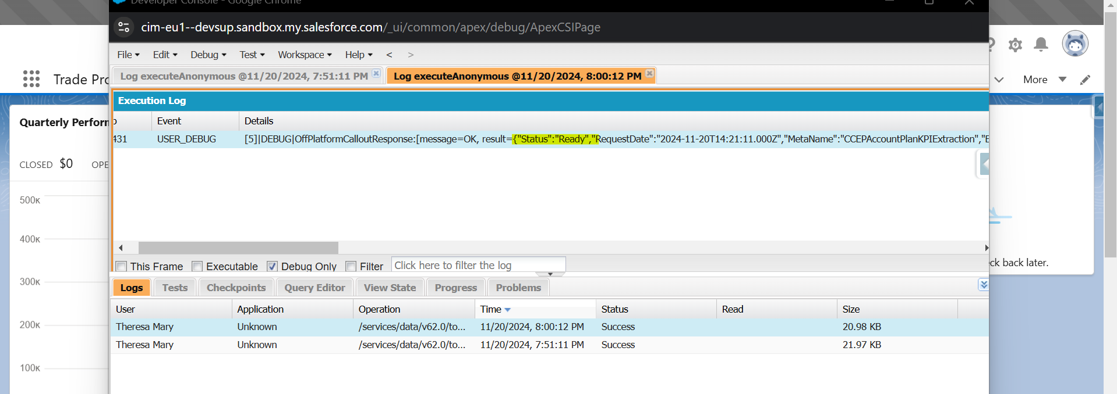

- COMMIT RTR EXPORT:

Execute the script below to commit the RTR export, ensure to replace the highlighted placeholders with the RTR report name and the CSV GUID.

CGCLOUD.OffPlatformCallout request = new CGCLOUD.OffPlatformCallout('COMMIT_RTR_EXPORT','DE00');
Map<String, Object> data = new Map<String, Object>();
data.put('metaname', 'CCEPAccountPlanKPIExtraction');
data.put('salesorg', 'DE00');
data.put('businessyear',2024);
data.put('backwardCompatibilityMode',true);
String requestBodyContent = JSON.serialize(data, true);
Map<String, String> params = new Map<String, String>();
params.put('csvGuid', '0b523edf-3aea-4165-a8a9-cd01e9e4e9e2');
CGCLOUD.OffPlatformCalloutResponse response = request.execute(CGCLOUD.TransactionHandler.getTransactionIdentifier(), params, requestBodyContent);
System.debug(response);

Once the status shows Committed, retrieve the CSV GUID and proceed with the Postman step to fetch the CSV extract. 